Practical :- 1

<!DOCTYPE html>
<html lang="en">
<head>
<meta charset="UTF-8">
<meta name="viewport" content="width=device-width, initial-scale=1.0">
<title>E-Commerce Website</title>
<link href="https://fonts.googleapis.com/css2?family=Poppins:wght@300;400;600&display=swap" rel="stylesheet">
<style>
*{
margin:0;
padding:0;
box-sizing:border-box;
font-family:'Poppins',sans-serif;
}
body{
background:#f5f7fa;
scroll-behavior:smooth;
}
/* Header */
header{
display:flex;
justify-content:space-between;
align-items:center;
padding:15px 50px;
background:#fff;
box-shadow:0 2px 10px rgba(0,0,0,0.1);
position:sticky;
top:0;
z-index:100;
}
.logo{
font-size:22px;
font-weight:600;
color:#4a90e2;
}
nav ul{
list-style:none;
display:flex;
gap:20px;
}
nav ul li a{
text-decoration:none;
color:#333;
font-weight:500;
transition:0.3s;
}
nav ul li a:hover{
color:#4a90e2;
}
.cart{
position:relative;
cursor:pointer;
}
.cart span{
position:absolute;
top:-8px;
right:-10px;
background:red;
color:#fff;
font-size:12px;
padding:2px 6px;
border-radius:50%;
}
/* Hero */
.hero{
height:60vh;
background:url('https://source.unsplash.com/1600x900/?shopping') no-repeat center/cover;
display:flex;
align-items:center;
justify-content:center;
color:#fff;
text-align:center;
}
.hero h1{
font-size:40px;
background:rgba(0,0,0,0.6);
padding:20px;
border-radius:10px;
}
/* Products */
.products{
padding:50px;
display:grid;
grid-template-columns:repeat(auto-fit,minmax(250px,1fr));
gap:25px;
}
.product{
background:#fff;
padding:15px;
border-radius:10px;
box-shadow:0 5px 15px rgba(0,0,0,0.1);
text-align:center;
transition:0.3s;
}
.product:hover{
transform:translateY(-5px);
}
.product img{
width:100%;
border-radius:10px;
}
.product h3{
margin:10px 0;
}
.price{
color:#4a90e2;
font-weight:600;
}
button{
margin-top:10px;
padding:8px 15px;
border:none;
background:#4a90e2;
color:#fff;
border-radius:5px;
cursor:pointer;
transition:0.3s;
}
button:hover{
background:#357abd;
}
/* Footer */
footer{
background:#222;
color:#fff;
text-align:center;
padding:20px;
margin-top:30px;
}
@media(max-width:768px){
header{
flex-direction:column;
gap:10px;
}
}
</style>
</head>
<body>
<header>
<div class="logo">ShopEase</div>
<nav>
<ul>
<li><a href="#">Home</a></li>
<li><a href="#">Shop</a></li>
<li><a href="#">About</a></li>
<li><a href="#">Contact</a></li>
</ul>
</nav>
<div class="cart">
🛒 <span id="cart-count">0</span>
</div>
</header>
<section class="hero">
<h1>Big Sale! Up to 50% Off</h1>
</section>
<section class="products"
<div class="product">
<img src="https://source.unsplash.com/300x300/?shoes" alt="">
<h3>Running Shoes</h3>
<p class="price">$59.99</p>
<p>⭐⭐⭐⭐☆</p>
<button onclick="addToCart()">Add to Cart</button>
</div>
<div class="product">
<img src="https://source.unsplash.com/300x300/?watch" alt="">
<h3>Smart Watch</h3>
<p class="price">$89.99</p>
<p>⭐⭐⭐⭐⭐</p>
<button onclick="addToCart()">Add to Cart</button>
</div>
<div class="product">
<img src="https://source.unsplash.com/300x300/?headphones" alt="">
<h3>Headphones</h3>
<p class="price">$39.99</p>
<p>⭐⭐⭐⭐☆</p>
<button onclick="addToCart()">Add to Cart</button>
</div>
<div class="product">
<img src="https://source.unsplash.com/300x300/?bag" alt="">
<h3>Backpack</h3>
<p class="price">$49.99</p>
<p>⭐⭐⭐⭐☆</p>
<button onclick="addToCart()">Add to Cart</button>
</div>
<div class="product">
<img src="https://source.unsplash.com/300x300/?laptop" alt="">
<h3>Laptop</h3>
<p class="price">$599.99</p>
<p>⭐⭐⭐⭐⭐</p>
<button onclick="addToCart()">Add to Cart</button>
</div>
<div class="product">
<img src="https://source.unsplash.com/300x300/?camera" alt="">
<h3>Camera</h3>
<p class="price">$299.99</p>
<p>⭐⭐⭐⭐☆</p>
<button onclick="addToCart()">Add to Cart</button>
</div>
</section>
<footer>
<p>© 2026 ShopEase | Contact: support@shopease.com</p>
</footer>
<script>
let count = 0;
function addToCart(){
count++;
document.getElementById("cart-count").innerText = count;
alert("Product added to cart!");
}
</script>
</body>
</html>
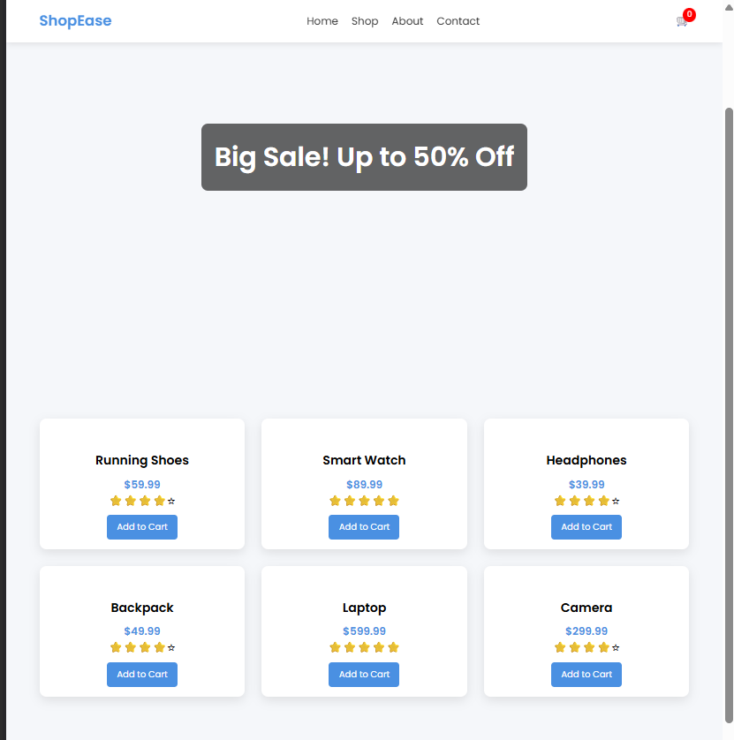

Practical :- 2

<!DOCTYPE html>
<html>
<head>
<title>Event Listener Example</title>
</head>
<body>
<button id="myButton">Click Me</button>
<script>
// Select the button
const button = document.getElementById("myButton");
// Add event listener
button.addEventListener("click", function() {
alert("Button was clicked!");
});
</script>
</body>
</html>
